**Overview**:

We are supposed to fit a regression model for the end-of-the-year values of DJIA. The file includes closing values for the last trading day of each year (DowClose) in the 1929-2017 period. A time index, t, average annual Gross Domestic Product (GDP) and Consumer Price Index (CPI) at the end of the year are also provided as potential predictors of DowClose.

 We have to predict DowClose for 2018 using past values of GDP and DowClose. We have used Minitab and IBM SPSS to predict the DowClose for the year of 2018.

**The final fitted regression model equation, including only significant predictors using Minitab and SPSS (Exhibits 1A, 1B)**

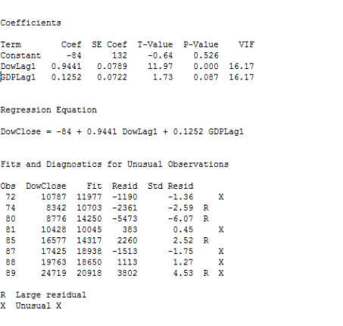

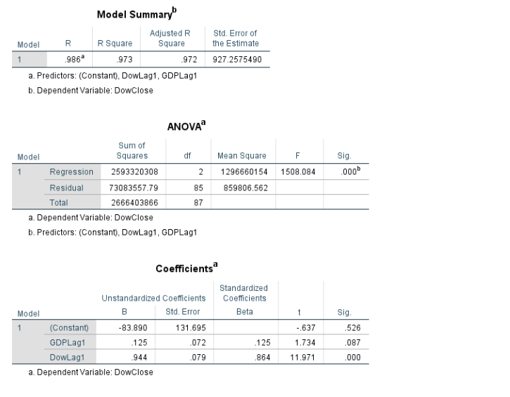

**Interpretation of each coefficient estimate in your final model**

In our final model, DowLag1 and GDPLag1 are the predictors and DowClose is the response variable. P value of DowLag1 is less 0.05 and hence it is a significant predictor.

**A residual plot (residuals vs. fitted values) for your final model using Minitab & SPSS (Exhibits 2A, 2B)**

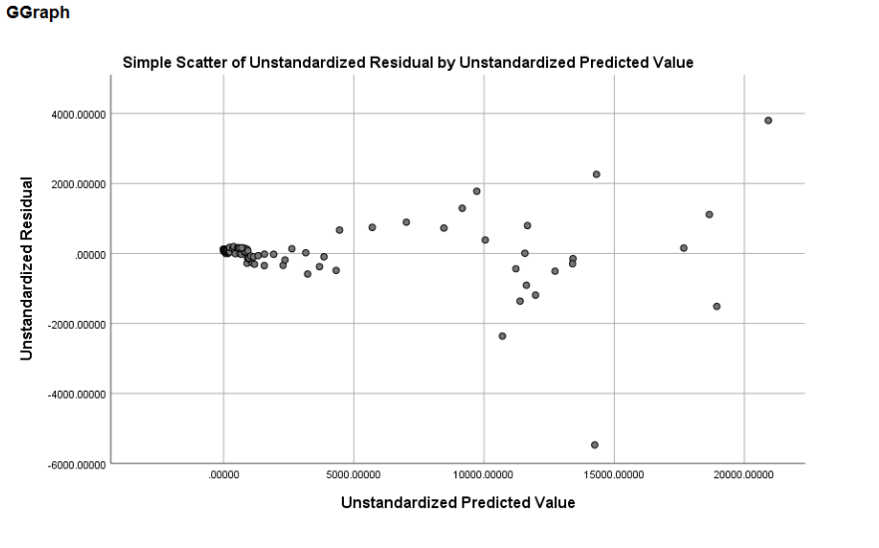

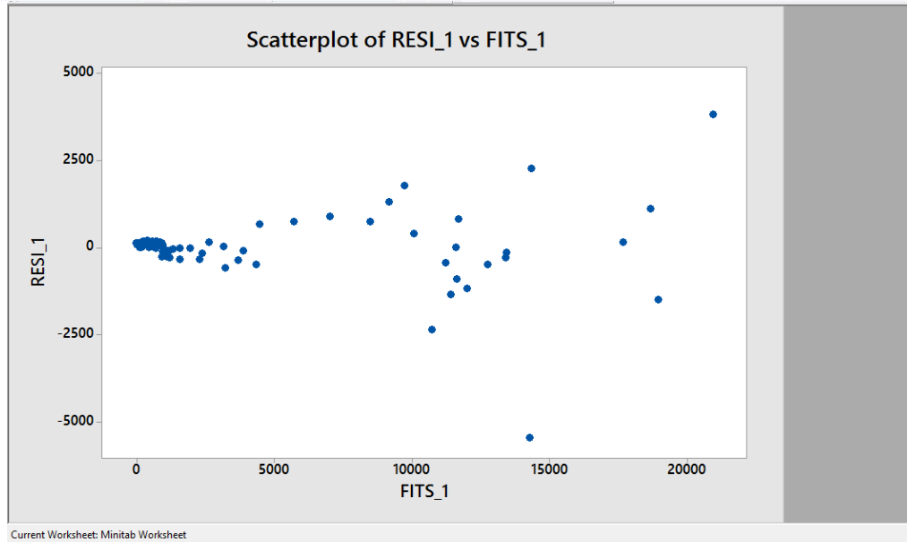

**Test of normality results for your final model using Minitab & SPSS (Exhibits 3A, 3B)**

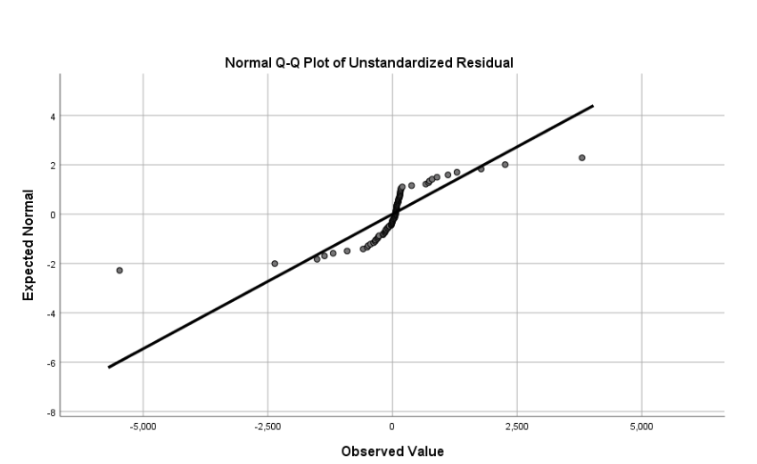

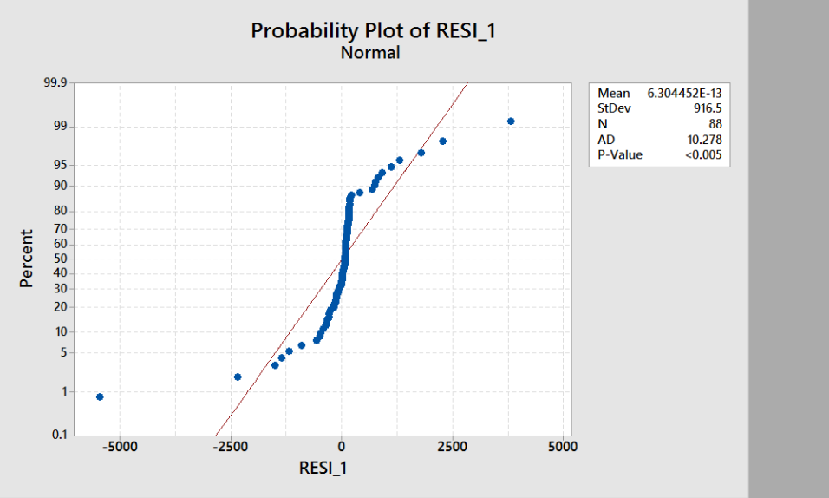

**ACF and PACF plots of the residuals of your final model, MTB/SPSS (Exhibits 4A, 4B)**

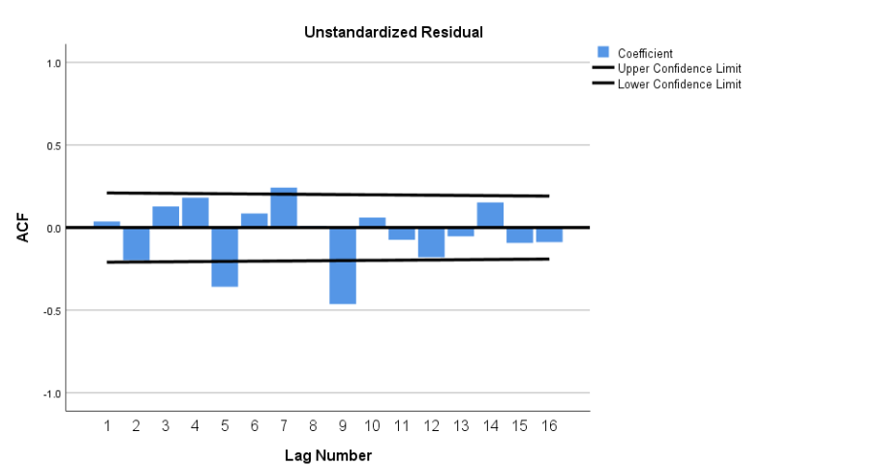

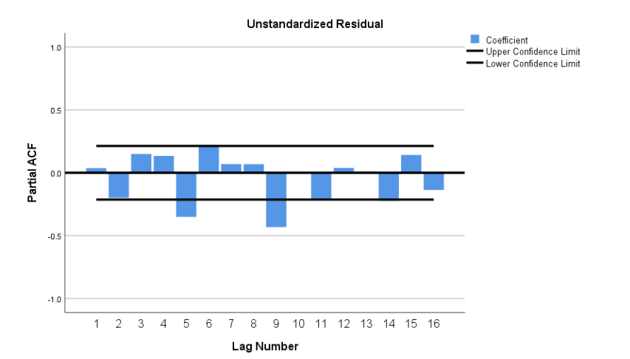

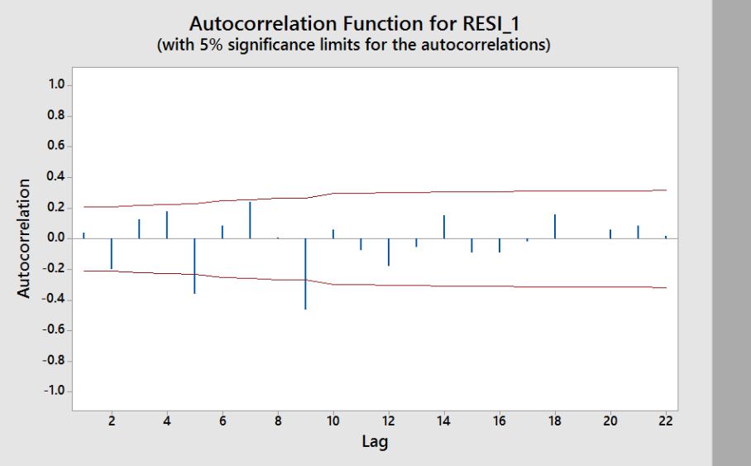

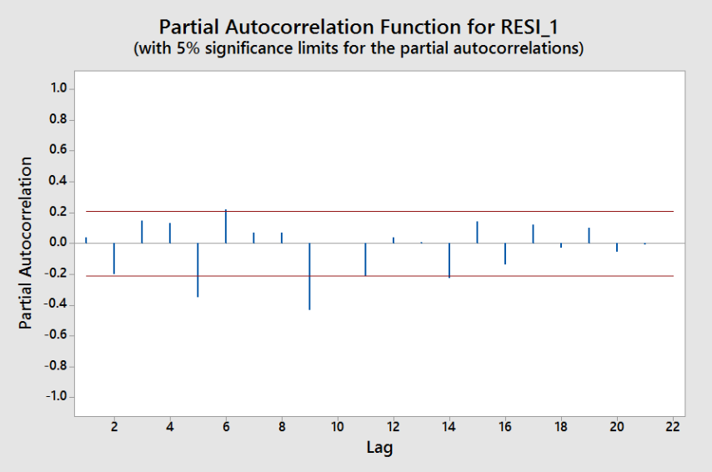

**Does your final model satisfy the model assumptions for error independence, constant variance, and normality?**

The model does not satisfy the model assumptions for error independence, constant variance, and normality. As per residual plot, our model fails to satisfy the error independence and constant variance condition.

Also, a normality test is used to determine whether sample data has been drawn from a normally distributed population. The p-value is less than 0.05, henve the null hypothesis that the data are normally distributed is rejected

**Fitted value, 95% CI, and 95% PI for a 2018 forecast of DowClose from Minitab and SPSS (Exhibits 5A, 5B)**

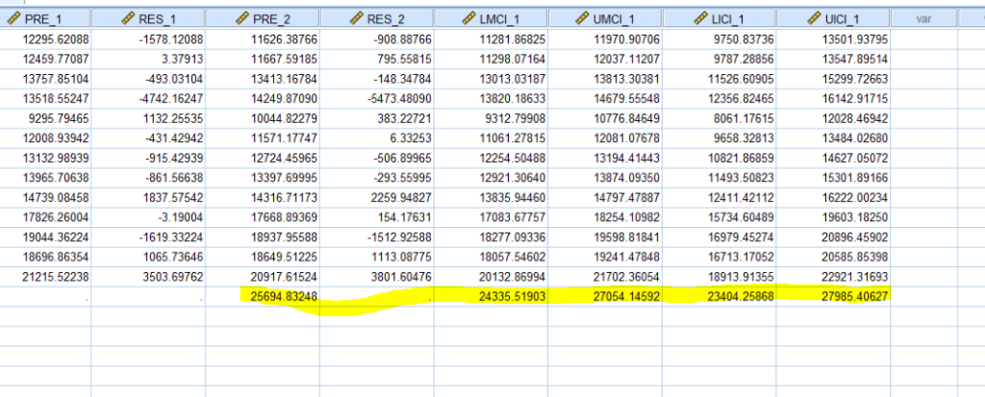

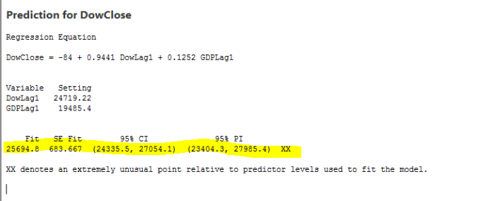

**December 31, 2018 update: On the last trading day of 2018, DJIA closed at 23,327.46. How does this compare to the point estimate your model predicts as of February 2018? The C.I.? The P.I.? Do you see any indication that the stock market is undervalued or overheated**?

Our prediction interval is between (23404.3, 279885.4) and predicted value is 25694.8. However, DJIA closed at 23,327.46. This means that we have overheated the stock market.

95% CI (24335.5, 27054.1)       95% PI (23404.3, 279885.4)